**3.3 WorkVisual and LAN connection between KRC4 and the KUKA-PC**

The WorkVisual software package is the engineering environment for KR C4 controlled robotic cells. It offers the following functionalities:

* Configuring and connecting field buses
* Programming robots offline
* Configuring machine data
* Configuring RoboTeams offline
* Editing the safety configuration
* Transferring projects to the robot controller
* Loading projects from the robot controller
* Comparing a project with another project and accepting differences where
* necessary
* Managing long texts
* Managing option packages
* Diagnostic functionality
* Online display of system information about the robot controller
* Configuring traces, starting recordings, evaluating traces (with the oscilloscope)

# Hardware requirements:

Minimum requirements

* PC with Pentium IV processor, min. 1500 MHz
* 512 MB RAM
* DirectX8-compatible graphics card with a resolution of 1024x768 pixels

Recommended specifications

* PC with Pentium IV processor and 2500 MHz
* 1 GB RAM
* DirectX8-compatible graphics card with a resolution of 1280x1024 pixels

# Software requirements:

* Windows 7 9Both the 32-bit version and the 64-bit version can be used).
* Or: Windows XP (32-bit version, with at least Service Pack 3, the 64-bit version cannot be used).

If the following software are not already installed on the PC, the installation wizard automatically starts their installation before preceding with the WorkVisual installation.

* .NET Framework 2.0, 3.0 and 3.5
* SQL Server Compact 3.5
* Visual C++ Runtime Libraries
* WinPcap

3.3.1 WorkVisual Installation

1. Start the program **setup.exe**.
2. If the following components are not yet installed on the PC, an installation wizard opens:

* NET Framework 2.0, 3.0 and 3.5

Follow the instructions in the installation wizard. .NET Framework is installed.

1. If the following component is not yet installed on the PC, an installation wizard opens:

* SQL Server Compact 3.5

Follow the instructions in the installation wizard. SQL Server Compact 3.5 is installed.

1. If the following components are not yet installed on the PC, an installation wizard opens:

* Visual C++ Runtime Libraries
* WinPcap

Follow the instructions in the installation wizard. Visual C++ Runtime Libraries and/or WinPcap is installed.

1. The **WorkVisual […] Setup** window opens. Click on **Next**.
2. Accept the license agreement and click on **Next**.
3. Click on the desired installation type.
4. Click on **Install**. WorkVisual is installed.
5. Once installation is completed, click on **Finish** to close the installation wizard.

For more information about installation, uninstallation and GUI of the WorkVisual software, please refer to Manual “**KST_WorkVisual_en”**.

# 3.3.2 LAN connection:

In order to start file sharing process and to be able to use all functions of WorkVisual, a PC-Controller connection must be established. There are several ways to connect the KRC4 and KUKA-PC, one of which is setting up a local network for the connection of between several devices. This can be done by either setting static IPs for the connected devices and connecting them physically using a specified Ethernet cable, or by using a network router and assign dynamic IPs starting from a specified value, with specified number of connected devices.

## To obtain and/or change IP values for the PC

1. Open network and sharing center
2. Choose change adapter settings
3. Right click Ethernet connections
4. Choose Internet protocol version 4 (TCP/IPv4)
5. Choose properties
6. Next you either set static IPs or choose dynamic IPs to be set, in our case by the router.

The following address ranges are used by default by the robot controller for internal purposes. IP addresses from this range must not therefore be assigned by the user.

* 192.168.0.0 … 192.168.0.255
* 172.16.0.0 … 172.16.255.255
* 172.17.0.0 … 172.17.255.255

## LAN Configuration steps:

1. Connect the PC and the KRC4 to the router using regular Ethernet cables.
2. Access the router configuration page using the given data on the back of the router. (the router used in our case is TP-LINK, with username and password both being **admin**)
3. In the **Interface setup** change the LAN settings to your preferred values
4. 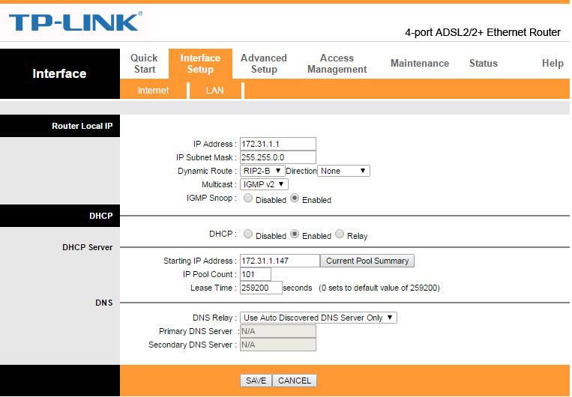It is preferred to set the starting IP address similar to that of the KRC4 (172.31.147) to avoid conflicts. Network gateway value is (172.31.1.1) and subnet mask (255.255.0.0), all other settings shall remain unchanged.
5. 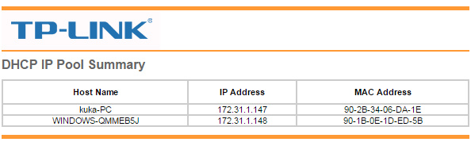After changing these values, the IP address used to access the router settings will change from (192.168.1.1) to the set gateway value (172.31.1.1) but with the same user name and password.
6. The connection is now established and can be verified by checking the router LEDs

**3.4 Installation and setup of KUKA.Sim Pro**

KUKA.Sim Pro is used for the complete offline programming of KUKA robots. This product allows the analysis of cycle times and the generation of robot programs. It also enables a real-time connection to the virtual KUKA robot controller (KUKA.OfficeLite). KUKA.Sim Pro is additionally used for building parametric components and defining kinematic systems, which can also be used in KUKA.Sim Layout and KUKA.Sim Tech. KUKA.OfficeLite is included in the KUKA.Sim Pro package. CAD importers are available as an option. This requires a purchasable license for each import interface.

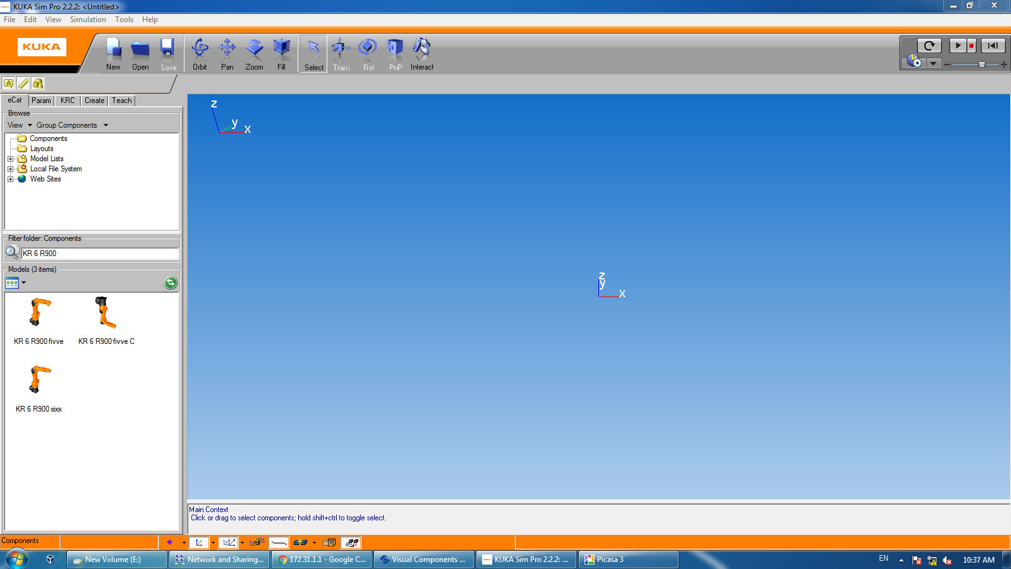Main window

Requirements:

* The minimum requirements for the computer are a 2 GHz CPU and 2 GB RAM, and an OpenGL-capable graphics card with at least 512 MB RAM and a resolution of 1024 x 768 pixels or a similarly specified notebook.
* Supported operating systems are WIN XP - 32-bit or WIN 7 - 32/64-bit.

**3.4.1 Installation:**

1. Start the setup file “.exe”
2. Read the agreement and activate the check box “I accept ...”
3. Select “Install” to start installation.
4. Select “Install” to complete installation

3.4.2 Installing the component library

After installation of the KUKA.Sim software product, the component library is installed with the following program: SetupKUKASimLibrary_2.2.0_Buildx.exe The procedure is very similar to the installation of the software products. Simply follow the instructions given.

The KUKA.Sim component library contains over 1,000 typical layout components (robots, grippers, fences, etc.), various demo layouts and tutorials for KUKA.Sim. Although the KUKA.Sim products still work without the component library installed, it is strongly recommended that the component library is installed in order to be able to create layouts quickly and easily.

3.4.3 License types:

There are different types of licensing for the KUKA software. License types are determined and verified in accordance with the purchase made from KUKA Roboter GmbH.

The software licensing concerning the KUKA arm at Zagazig university is an educational bundle license. The serial number for the license is found in the booklet of the KUKA.Sim Pro CD. Information about different licensing bundles are obtained by contacting KUKA Roboter GmbH by email [simulation@kuka-roboter.de](mailto:simulation@kuka-roboter.de).

Further details about the steps of obtaining the serial key, for different commercial bundles, are found on page 13 of **(KUKA.Sim_2.2_Installation_en)** manual.

The serial number associated with this purchase is: K5P22-N174H-AW7KY-9

1. Stand-alone license:

The license is on the PC on which KUKA.Sim is used. The license key is then valid for this PC only. It can also be transferred to a different PC, but cannot be used on a two different PCs at the same time, or when either of the two PCs is off.

2. Network license:

Network licenses provide a flexible way of using KUKA.Sim on more than one PC. When a license is requested by a PC, this license is then allocated to this PC. When KUKA.Sim is closed, the license becomes available again and can be accessed by other PCs.

A license server is required to manage the network licenses. When KUKA.Sim Pro is started, the computer’s identity (IP address, please refer to section “**3.3.2 LAN connection”** in Section **“WorkVisual & LAN connection”**) is required occasionally, however, KUKA.Sim Pro needs to check with the local license server to make sure that KUKA.Sim Pro and server are on the same PC, which is required in the network license configuration.

**2.1 Requesting a license file manually**

1. Start the installation of KUKA.Sim Pro
2. Enter the license key
3. Select “Activate manually” and save the request file
4. Go to the Visual components customer portal and use the given email and password, mentioned in the previous section, to login.
5. On the website, choose Manual Licensing, upload the request file and confirm.

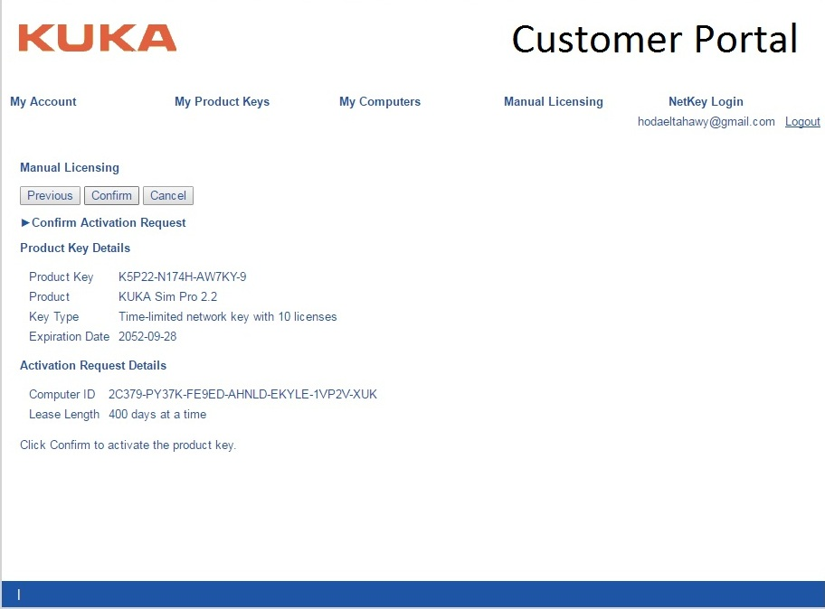

1. The license should be activated
2. Download the license (.dat) file and click Finish. Please complete the installation steps of the license server before proceeding with the next steps.
3. 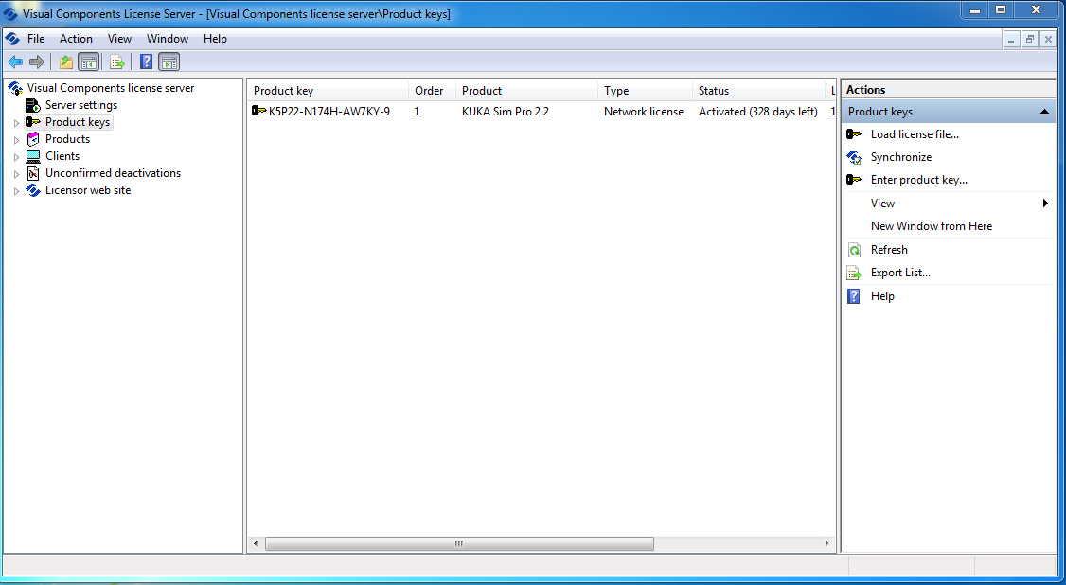The license (.dat) file should be loaded into the license server, not the KUKA.Sim Pro interface, in order to complete the activation process.
4. After this process is completed, the network server interface should appear as follows

2.1 Installing the license server:

**Requirements**: “Microsoft Management Console” (MMC) must be installed on the license server. The software can be downloaded from the Microsoft website. In addition, “.NET framework 3.5” or higher should be installed.

**Installation:**

1. The license server is started via “Start > Programs > Visual Components > Visual Components License Server > Visual Components License Server Manager”.
2. Choose “Server settings” from the left panel, make sure that the license server is started, if not, click **Start** to activate it. The **port number value is 5093.**
3. On the left-hand side, select “Product keys” in order to enter the license key.

* The right-hand side changes and “Enter product key...” is offered. Click on this.
* A window is opened in the center, in which the license key can be entered.
* If manual licensing is being performed using a license file, this license file must be loaded with “Load license file...”.

1. Enter the license key and confirm with OK.

For network licensing, an account linked with the purchase is created on the Visual Components website (<http://www.visualcomponents.com/>). In the specified customer portal (<https://portal.visualcomponents.net/website/Login.aspx>), sign in with the email [hodaeltahawy@gmail.com](mailto:hodaeltahawy@gmail.com) and password quails@123 . In the “My Products keys” tab, you will find the product key for KUKA.Sim Pro on the KUKA-PC device, at the Mechatronics lab. The license **is already activated** and will only require renewal after a period of 400 days starting 3-12-2016, which is on 7-1-2018.

References

1. KUKA manual **“KST_WorkVisual_en”**
2. KUKA manual **“KUKA.Sim_2.2_Installation_en”**